**Transfer data from EFS to S3 using Datasync**

Create EFS and mount into Linux Ec2 Machine

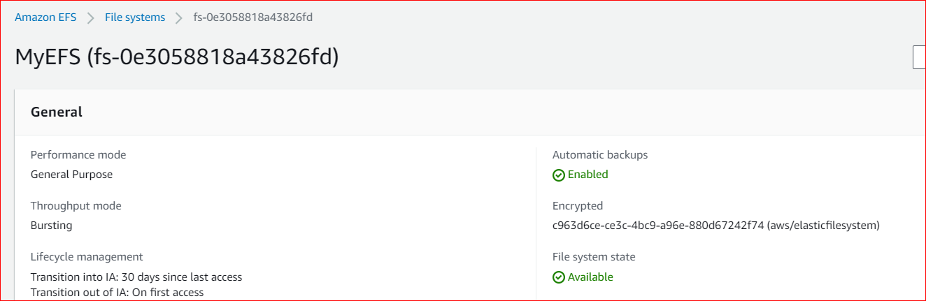

Launch EC2 instance with necessary nfs pre-request and mount the EFS file system.

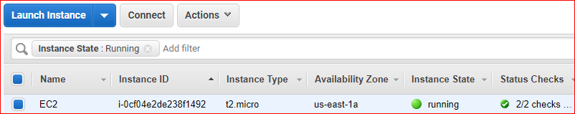

# mount -t nfs4 -o nfsvers=4.1,rsize=1048576,wsize=1048576,hard,timeo=600,retrans=2,noresvport fs-0e3058818a43826fd.efs.us-east-2.amazonaws.com:/ efs



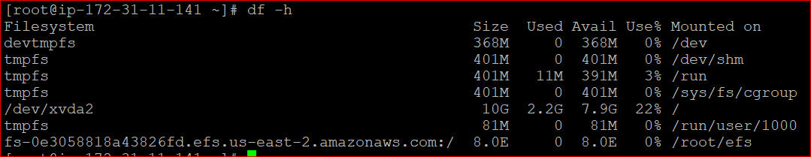

Objects not available in the destination S3.

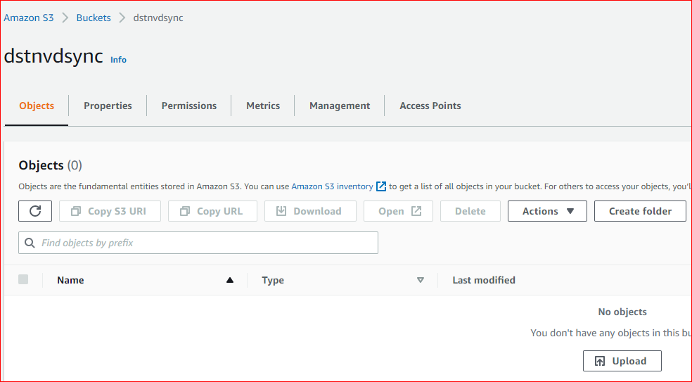

Create a task in Datasync

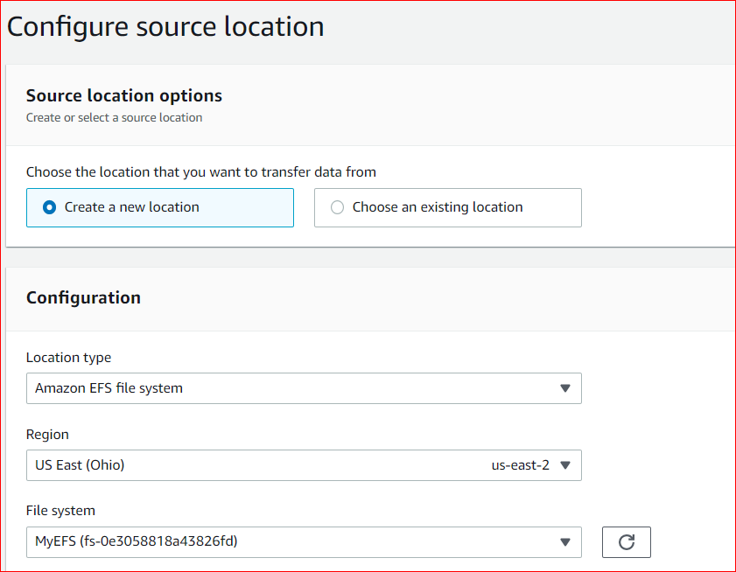

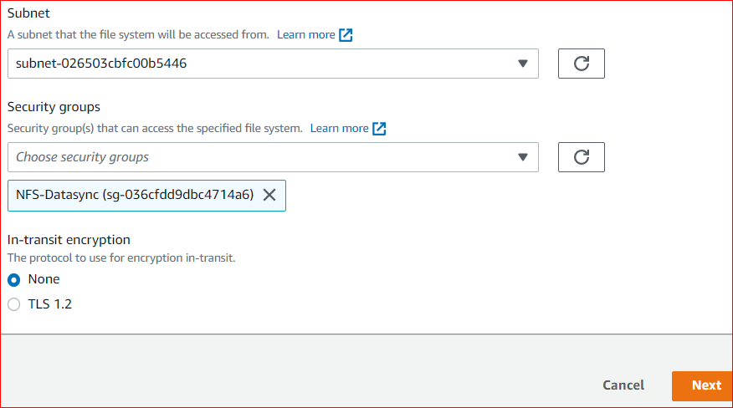

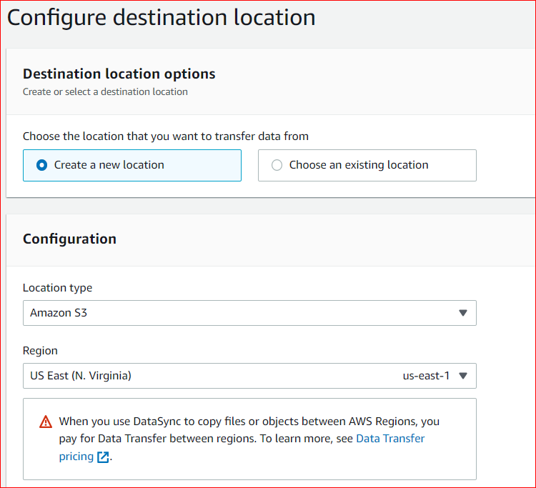

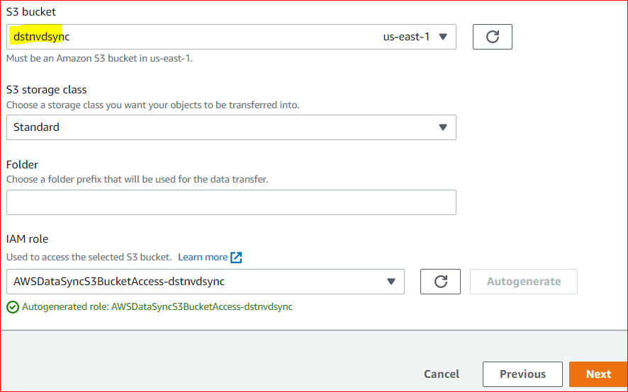

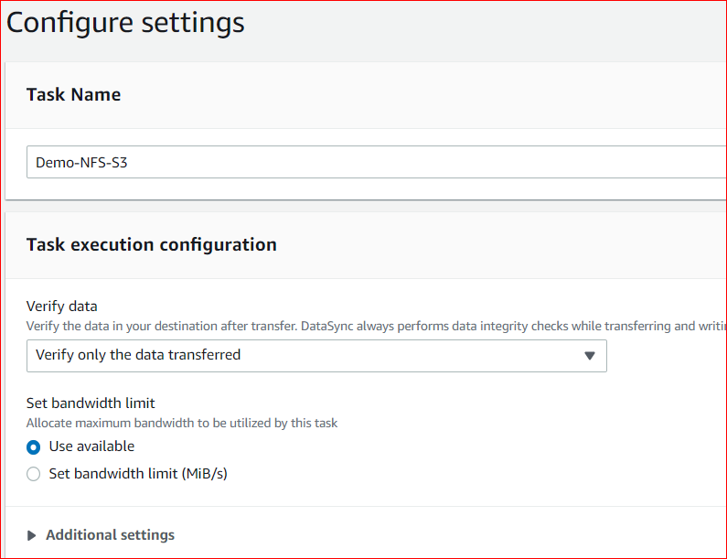

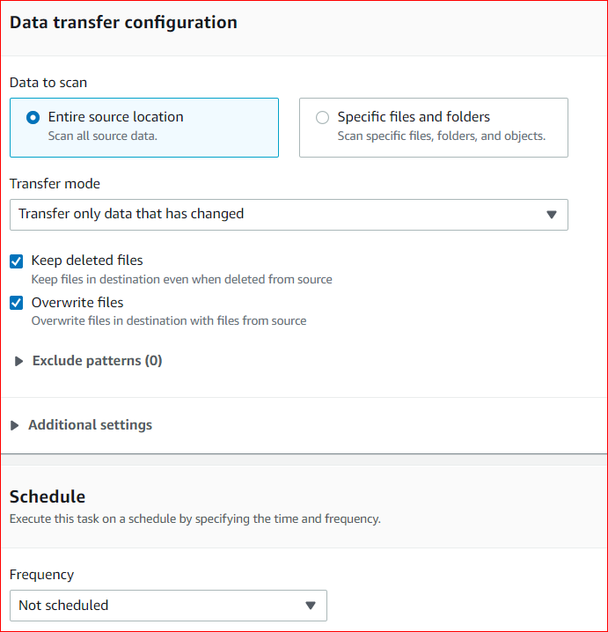

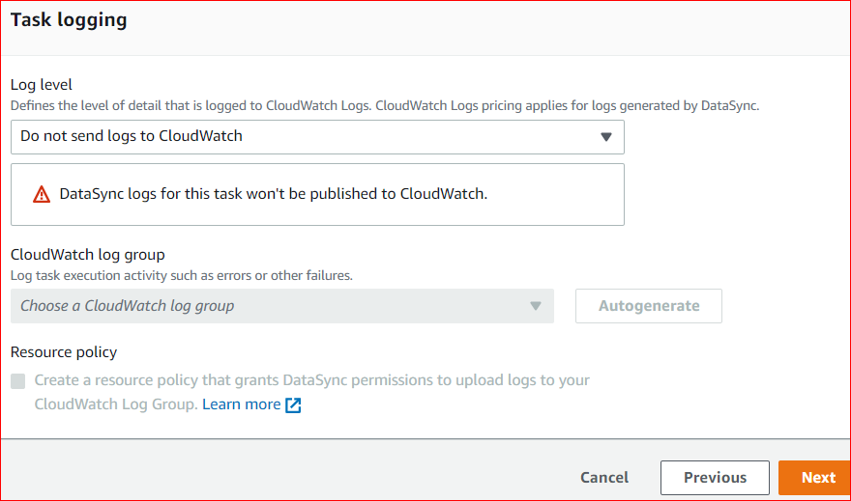

Review the configuration

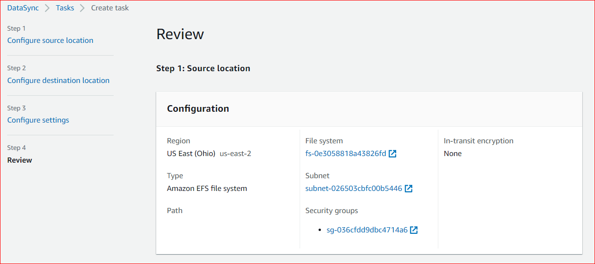

Task has been created and start the Task.

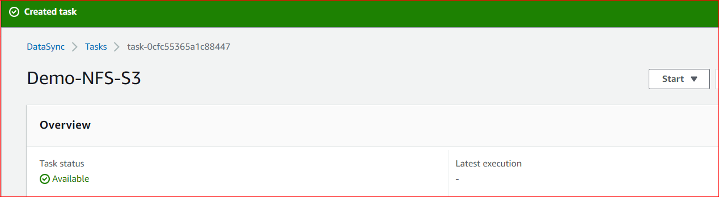

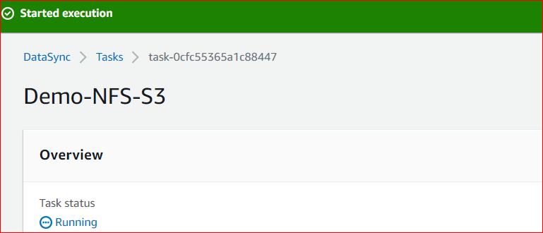

Datasync task completed Successfully.

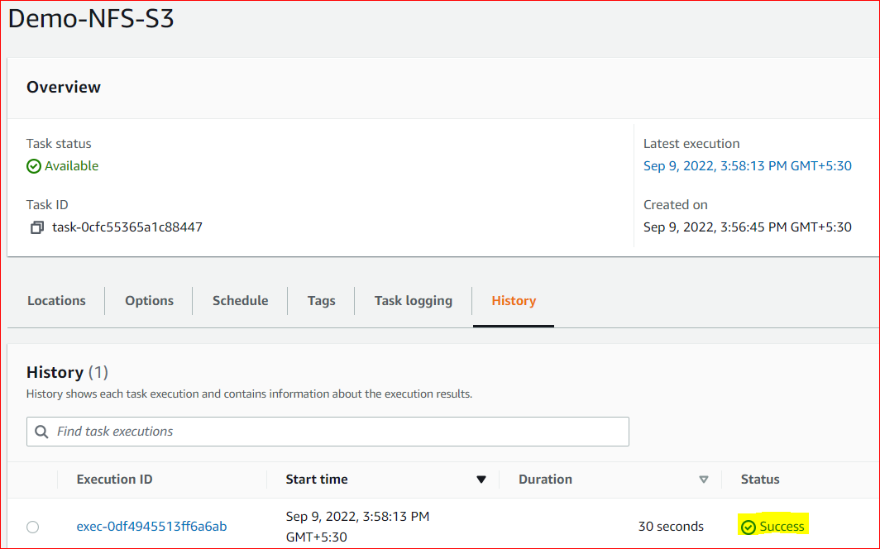

File from NFS to S3 transferred successfully.

